Assignment 2
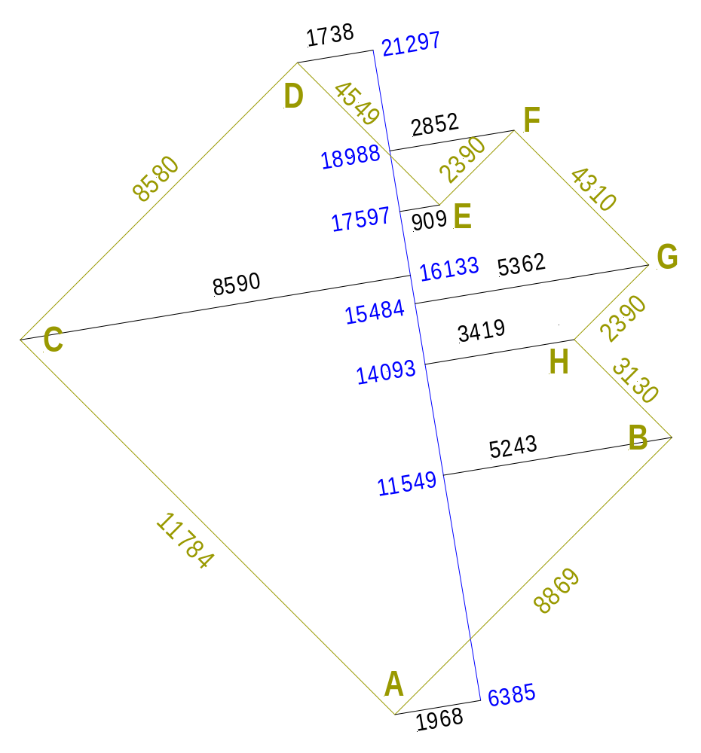
Side | coord. X |  | Sum X | coord Y |  | Sum Y | X² | Y² | (X+Y)² | Length
AB | 5.243 | 1.968 | 7.211 | 11.549 | 6.385 | 5.164 | 51.999 | 26.667 | 78.665 | 8.869
CD | 8.590 | 1.738 | 6.852 | 21.297 | 16.133 | 5.164 | 46.950 | 26.667 | 73.617 | 8.580
AC | 8.590 | 1.968 | 6.622 | 16.133 | 6.385 | 9.748 | 43.851 | 95.024 | 138.874 | 11.784
DE | 1.738 | 0.909 | 2.647 | 21.297 | 17.597 | 3.700 | 7.007 | 13.690 | 20.697 | 4.549
EF | 2.852 | 0.909 | 1.943 | 18.988 | 17.597 | 1.391 | 3.775 | 1.935 | 5.710 | 2.390
FG | 5.362 | 2.852 | 2.51 | 18.988 | 15.484 | 3.504 | 6.300 | 12.278 | 18.578 | 4.310
GH | 15.484 | 14.093 | 1.391 | 5.362 | 3.419 | 1.943 | 1.935 | 3.775 | 5.710 | 2.390
HB | 14.09 | 11.549 | 2.544 | 5.243 | 3.419 | 1.824 | 6.472 | 3.327 | 9.799 | 3.130

